**PictureBox Opacity**

You can find the completed version of this program on GitHub:

This tutorial will cover how to change the **opacity** of an image in a PictureBox. You may use your own image files, or download the ones that will be used in the example program.

Create a new project. Give it an appropriate name.

Import *slimer.png* and *haunted_background.png* into the project resources.

Set the **Background Image** property of your Form to the haunted_background image from resources.

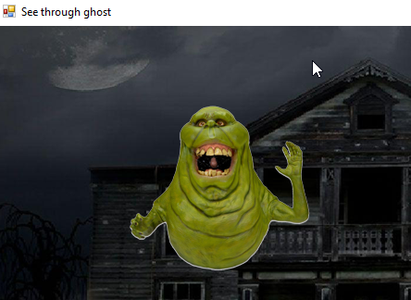Add a PictureBox and:

* Give it an appropriate name (we will use

imgSlimer for this tutorial)

* Set the image of this PictureBox to slimer

from Resources

* Make the Background_Color Transparent

Add a Button and name it btnFadeOut with Text “Fade Out”

Add another Button named btnFadeIn with Text “Fade In”

Add another Button named btnAppear with Text “Appear”

In the code editor, at the very top, add the following import statement:

Imports System.Drawing.Imaging

Inside your class, add the following function:

Public Shared Function ChangeOpacity(ByVal img As Image, ByVal opacityvalue As Single) As Bitmap

Dim bmp As New Bitmap(img.Width, img.Height)

Dim graphics__1 As Graphics = Graphics.FromImage(bmp)

Dim colormatrix As New Imaging.ColorMatrix

colormatrix.Matrix33 = opacityvalue

Dim imgAttribute As New ImageAttributes

imgAttribute.SetColorMatrix(colormatrix, ColorMatrixFlag.[Default], ColorAdjustType.Bitmap)

graphics__1.DrawImage(img, New Rectangle(0, 0, bmp.Width, bmp.Height), 0, 0, img.Width, img.Height,

GraphicsUnit.Pixel, imgAttribute)

graphics__1.Dispose()

Return bmp

End Function

We can use this function to set the opacity of an image in a PictureBox.

**btnFadeOut**

Add the following line of code to its **Click** event:

imgSlimer.Image = ChangeOpacity(imgSlimer.Image, 0.8)

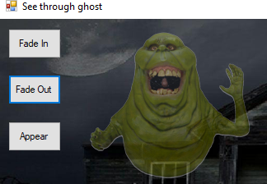

Try some different values for the **opacityvalue**. Keep the values between 0 and 1.

*What happens as you make the number smaller/larger?*

*What happens if you click on the Button repeatedly?*

**btnFadeIn**

Add the following line of code to its **Click** event:

imgSlimer.Image = ChangeOpacity(imgSlimer.Image, 1.2)

Try some different values for the **opacityvalue**. Keep the values greater than 1 (but still small).

*What happens as you make the number smaller/larger?*

*What happens if you click on the button repeatedly?*

**btnAppear**

To make slimmer re-appear fully, the best way is to dispose of the current image and reset it with the following code:

imgSlimer.Image.Dispose()

imgSlimer.Image = My.Resources.slimer

**Things to try on your own:**

* Add a **TextBox** so that the user can type an opacity value and click a Button to apply it.
  + You will need a Double variable for the **opacityvalue**.
  + Use the code from **btnAppear** to start with a fully opaque image each time.
  + Can you make it so that the user can type a number between 1 and 10 instead?

1. 0.1

5 0.5

10 1

* See if you can add a **Timer**(s) to make slimmer slowly fade in, and/or out.
  + You will need a Double variable for the **opacityvalue**.
* Try to use a **TrackBar** to allow the user to select its opacity.
  + You will need a Double variable for the **opacityvalue**.
  + Set the max/min properties to 0 and 10.
  + Use the Scroll event to read in the value, and reset the image each time.